# Lab Practical #01:

1. **Study of various templates. E.g. Metronic, Unify, AdminLTE, etc.**
2. **Short note on the observation you made from the Metronic templates.**

|  |
| --- |
| * Metronic templates stand out for their comprehensive and user-friendly design. They prioritize a clean and intuitive interface, enhancing user experience. * Notably, Metronic excels in responsiveness, ensuring seamless functionality across diverse devices. * The templates offer a wide array of pre-built components, streamlining development and reducing coding efforts. * Customization is a key strength, allowing developers to tailor designs to specific project needs. * Metronic integrates seamlessly with popular front-end frameworks, enhancing its versatility. * Metronic templates go beyond mere design aesthetics; they offer a holistic approach to web development. * The user-friendly design is complemented by an extensive set of features, including robust data tables, charts, and maps. * Metronic's customization capabilities extend to themes, layouts, and color schemes, allowing developers to create a unique visual identity. * The templates also provide advanced functionalities like form validations and wizards, streamlining complex processes. * Furthermore, Metronic's modular architecture facilitates scalability, making it suitable for a wide range of projects. |

1. **Short note on the observation you made from the Unify templates.**

|  |
| --- |
| * Unify templates are known for their modern and visually appealing design. * They emphasize responsiveness, adapting seamlessly to various devices and screen sizes. * The templates provide a rich collection of pre-built components, expediting development and promoting consistency. * Unify's strength lies in its thoughtful integration with popular front-end frameworks, ensuring compatibility with existing development ecosystems. * The templates offer sophistication in design, making them a valuable resource for creating contemporary and efficient web interfaces. * Unify templates not only prioritize modern design but also emphasize user engagement. * With a focus on seamless navigation, Unify integrates smooth transitions and animations into its components. * The templates include advanced UI elements such as sliders, calendars, and timelines, enhancing the richness of the user experience. * Unify's asset management features, including a dedicated assets panel, make it easy to organize and reuse design elements efficiently. * Collaboration is facilitated through real-time commenting, making it an excellent choice for teams working on design projects. |

1. **Short note on the observation you made from the AdminLTE templates.**

|  |
| --- |
| * AdminLTE templates excel in sleek and professional design, contributing to an aesthetically pleasing and intuitive user interface. * They prioritize responsiveness, ensuring a consistent user experience across different devices. * AdminLTE templates offer a comprehensive set of UI components and plugins, simplifying the development process. * Their compatibility and integration capabilities with popular front-end frameworks enhance flexibility. * AdminLTE templates are recognized for creating efficient, visually appealing, and user-friendly admin interfaces, making them a powerful tool for developers in building robust web applications. * AdminLTE templates stand out for their balance between professionalism and functionality. * They offer a suite of tools for data visualization, including interactive charts and graphs. * The templates prioritize user management, providing features for role-based access control and user authentication. * AdminLTE's documentation and community support contribute to its user-friendliness, making it accessible for developers at various skill levels. * Additionally, the templates include a range of utility classes, enhancing flexibility and enabling developers to fine-tune the layout and styling according to project requirements. |

1. **Installation of Figma on local machine and understanding the Figma software IDE**

**Steps of Installation:**

|  |
| --- |
| Step 1:  Download and Install:  Locate the download section on the website and choose the version compatible with your operating system (Windows, macOS, or Linux). Follow the prompts to download and install the software. |

|  |
| --- |
| Step 2:  Create an Account:  Upon installation, open Figma. If you don't have an account, you'll need to create one. Figma accounts are essential for saving and collaborating on design projects. |

|  |
| --- |
| Step 3:  Login:  After creating an account, log in to Figma using your credentials. |

# Lab Practical #02:

1. Develop 1 mobile and 1 web screen using the tools listed below:

Basic Tools: Position, Size, Rotation, Color Styles, Masks, Dark Mode with Selection Colors, Gradients, Creating Backgrounds.

1. Web Screen.

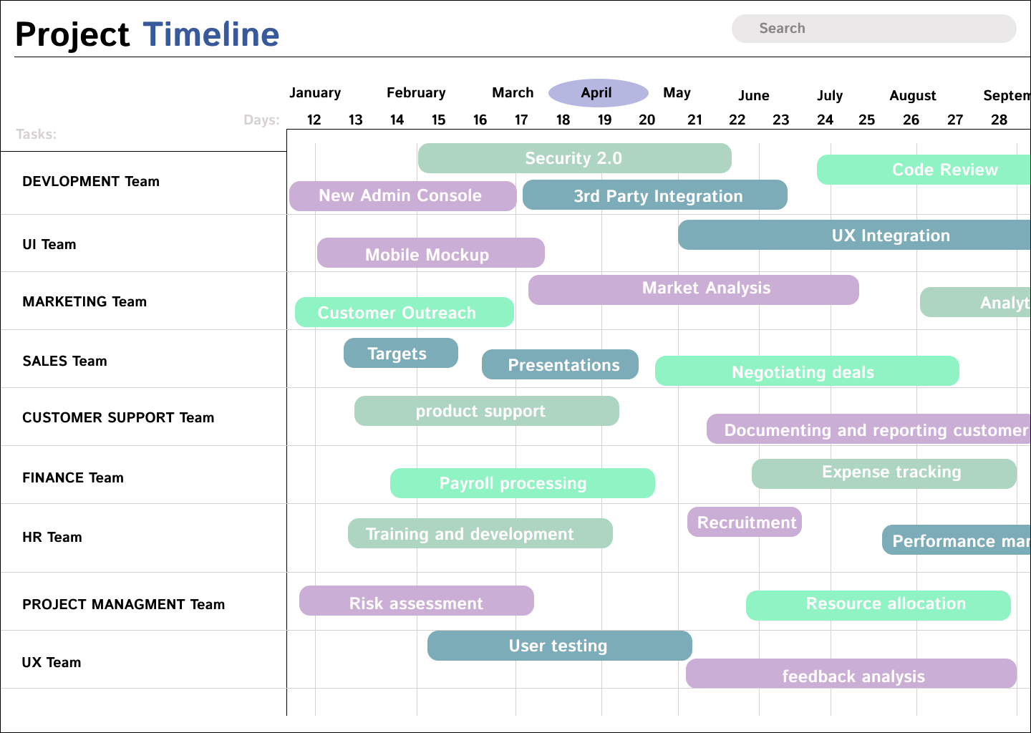

1. Mobile Screen.

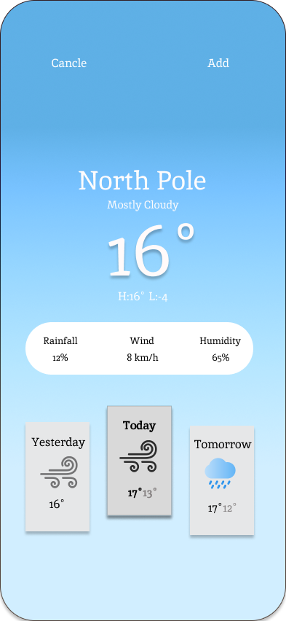

# Lab Practical #03:

1. Develop 1 mobile and 1 web screen using the tools listed below:

Blending Modes, Alignment, & Distribution, Union and Corner Radius, Shadow, Blur Effects, Using Images, Fill, & Stroke, Text Properties & Styles.

1. Web Screen.

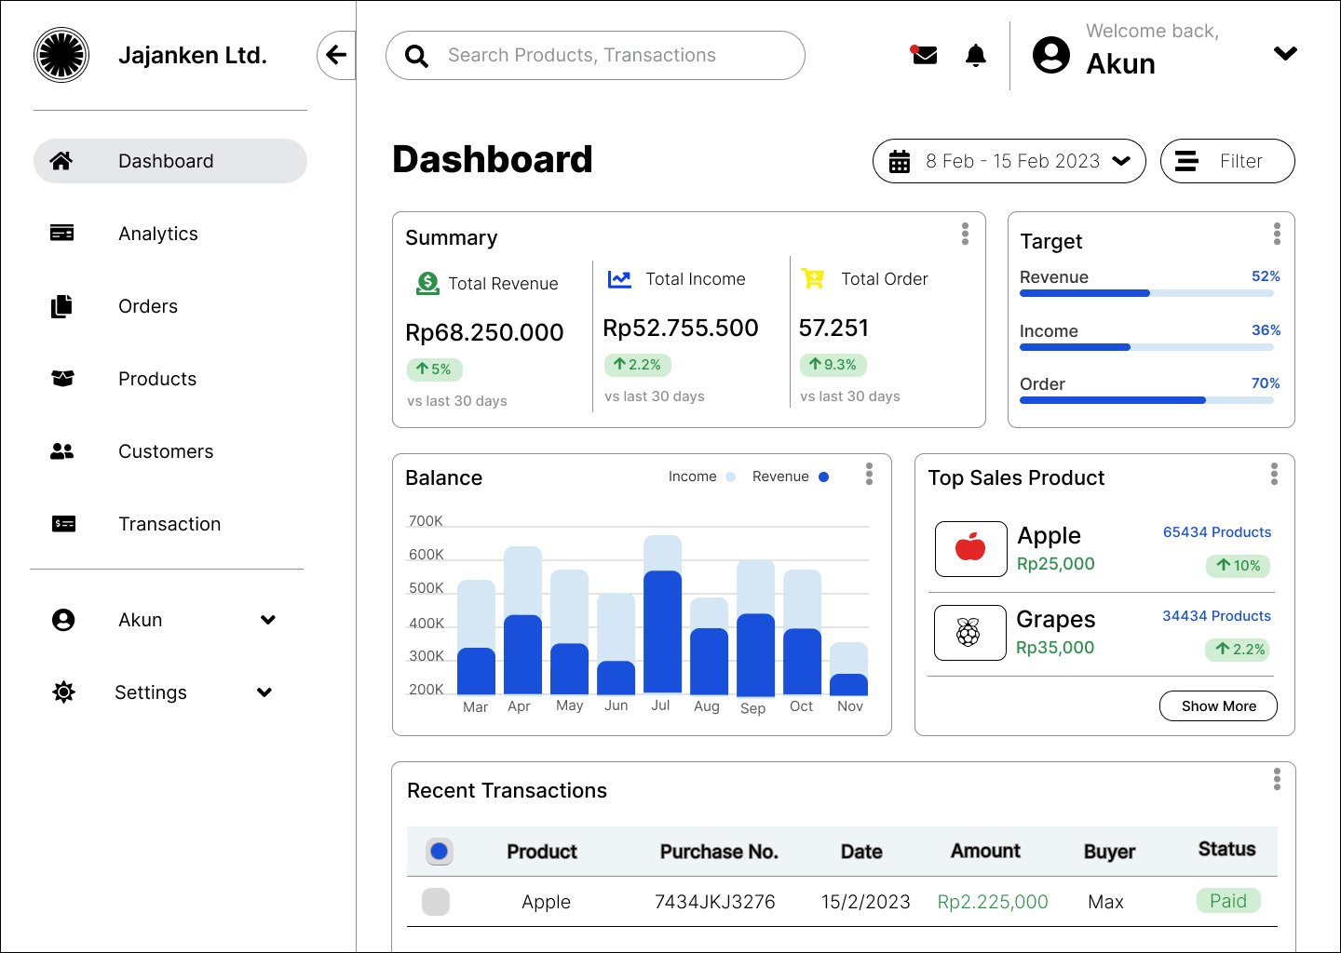

1. Mobile Screen.

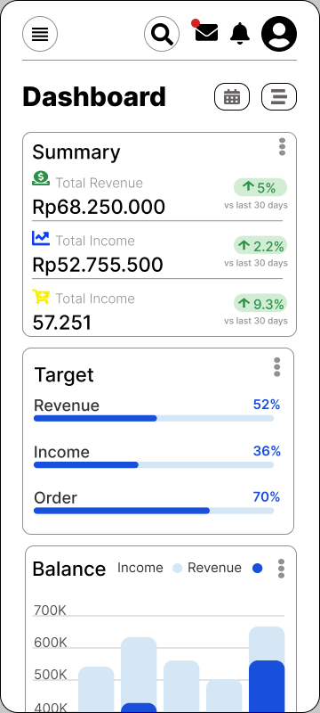

# Lab Practical #04:

1. Develop 1 mobile and 1 web screen using the tools listed below:

Google & Custom Fonts, Accessibility, Responsive Design, Constraints, Layout Grid, Auto Layout in Figma, Prototyping, Plugins in Figma.

1. Web Screen.

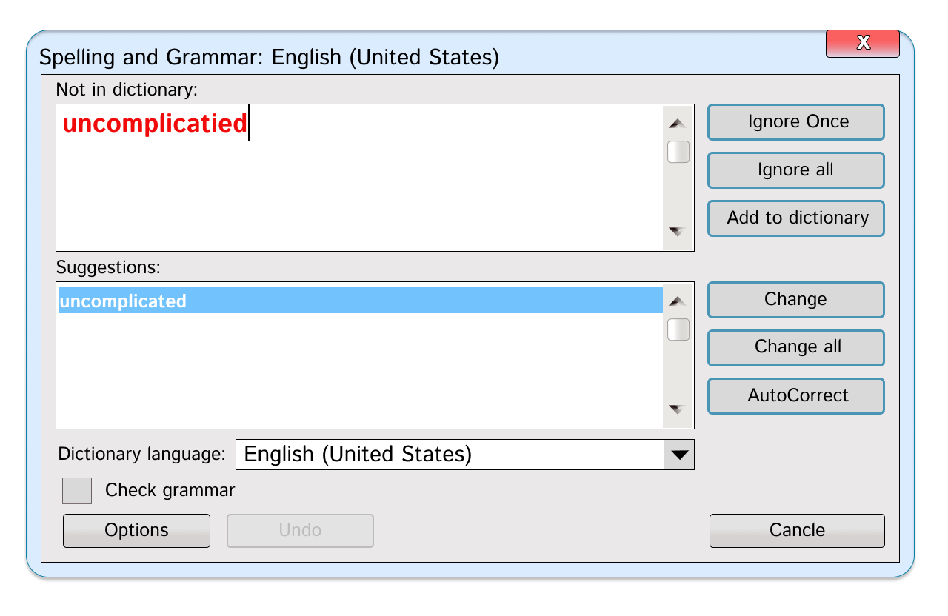

1. Mobile Screen.

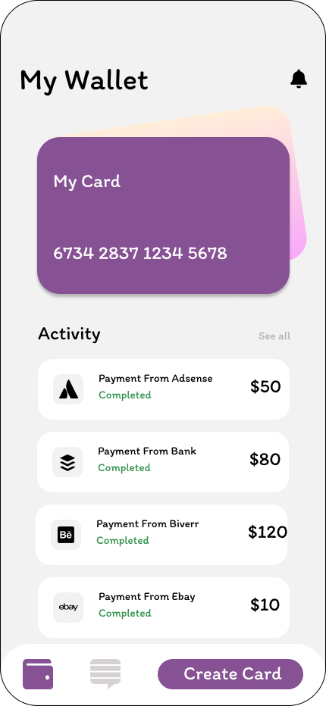

# Lab Practical #05:

1. Create login, registration/signup, forgot/reset password screen for your project.
2. Login Screen.

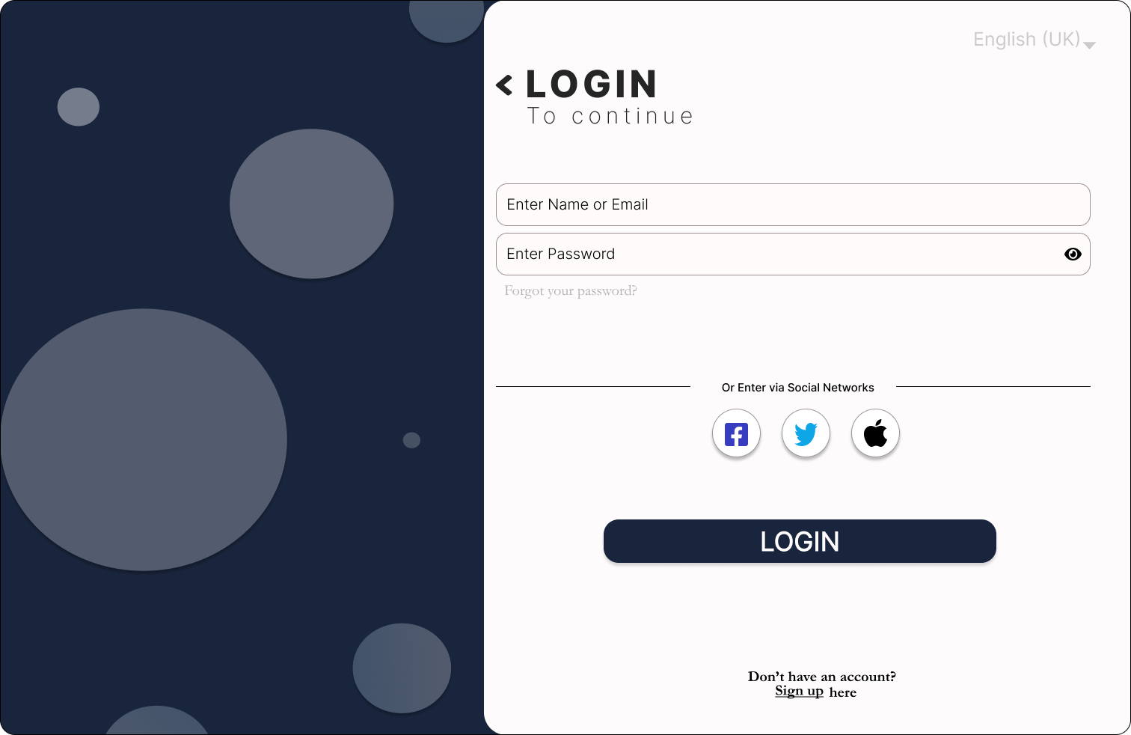

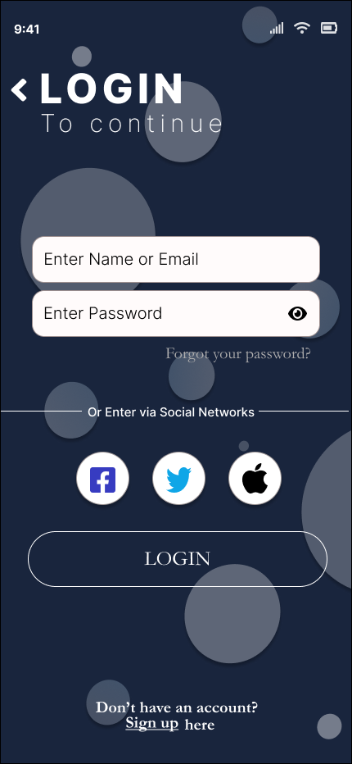

1. Registration / Signup Screen.

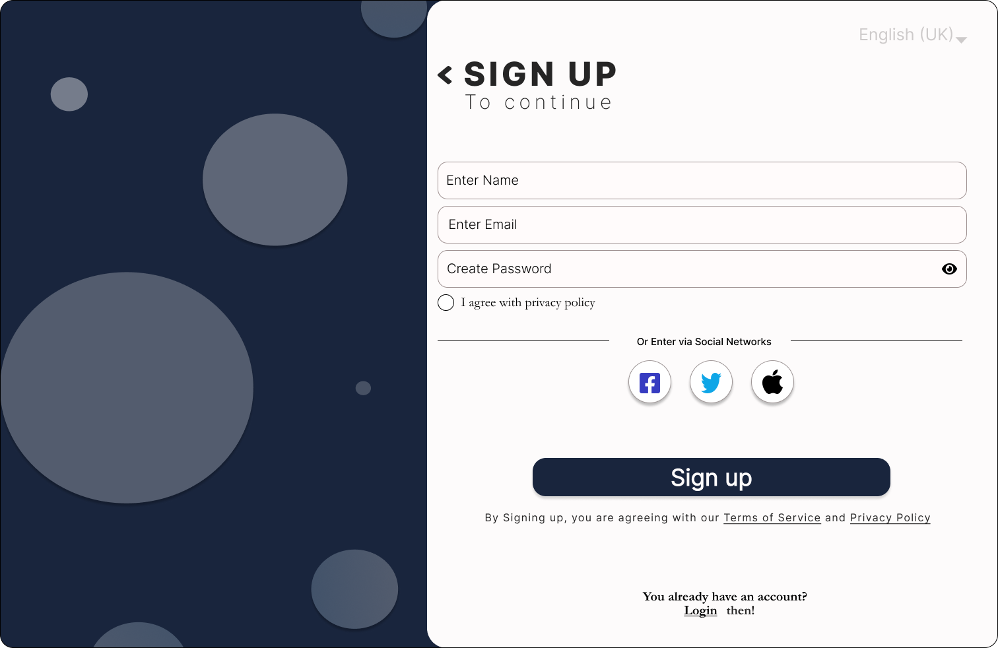

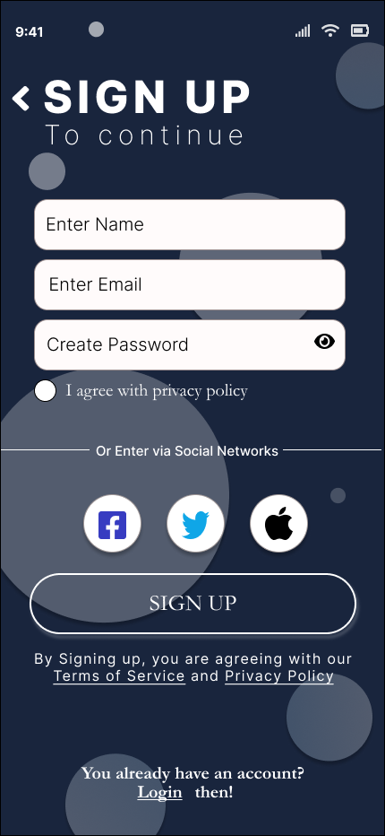

1. Forgot/Reset Password Screen.

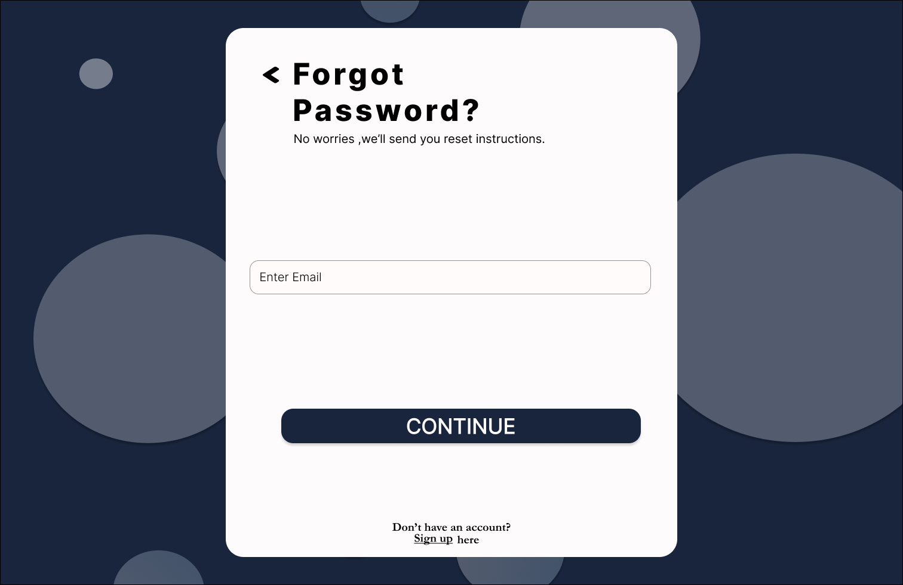

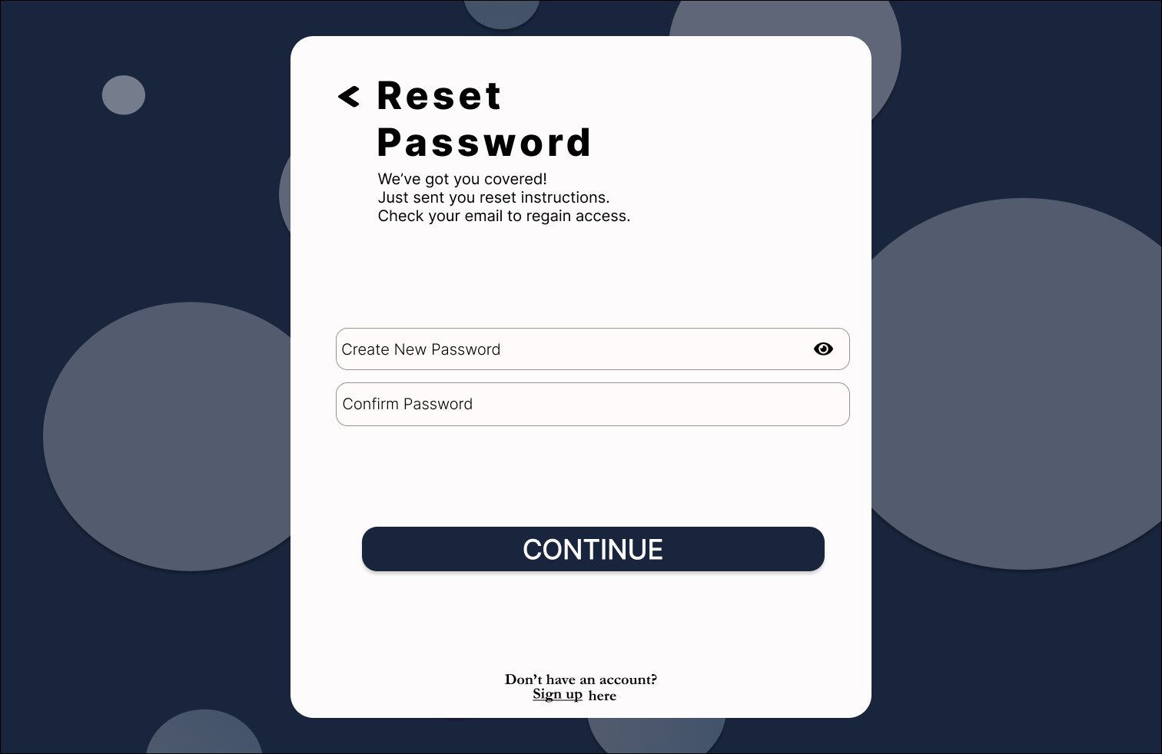

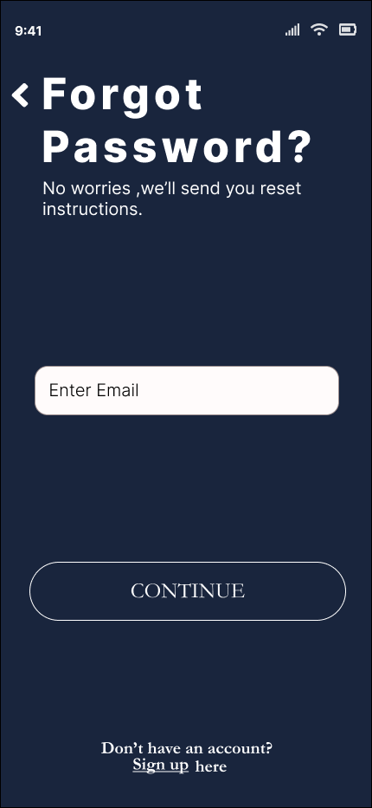

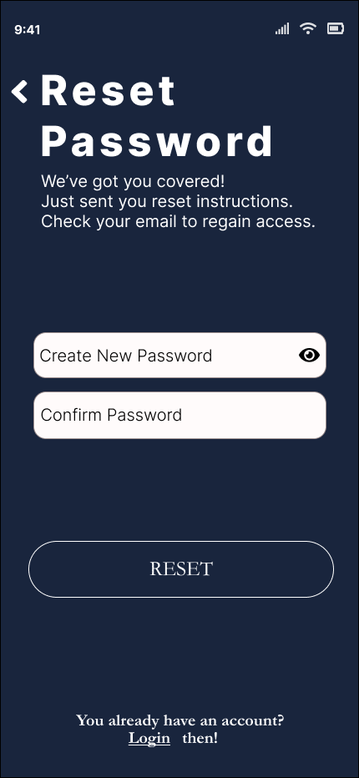

# Lab Practical #06:

1. Create dashboard for your project.
2. Dashboard Screen.

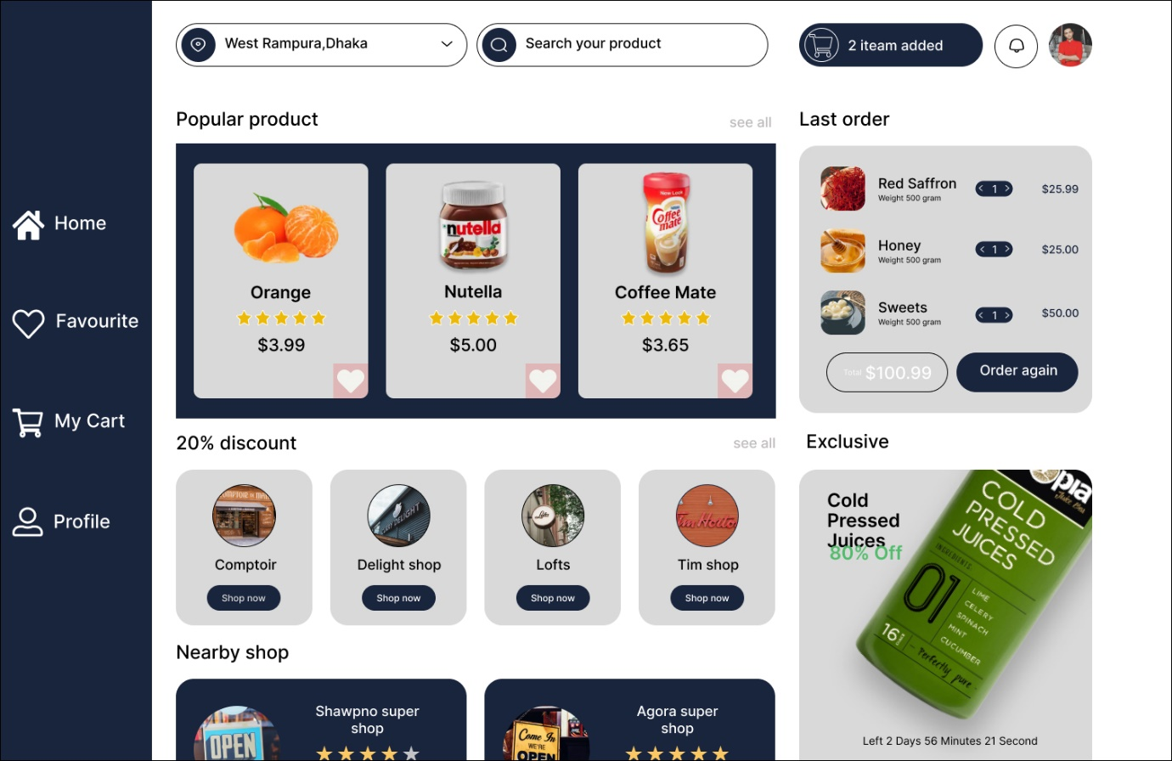

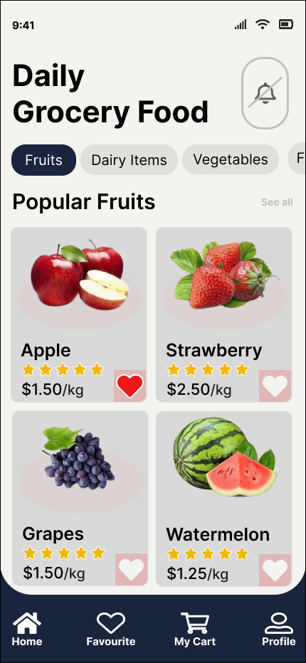

# Lab Practical #07:

1. Create screens to edit/view user profile – account information.
2. View User Profile Screen.

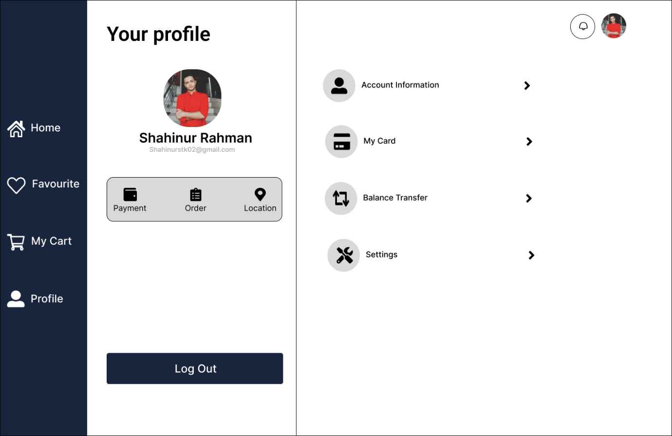

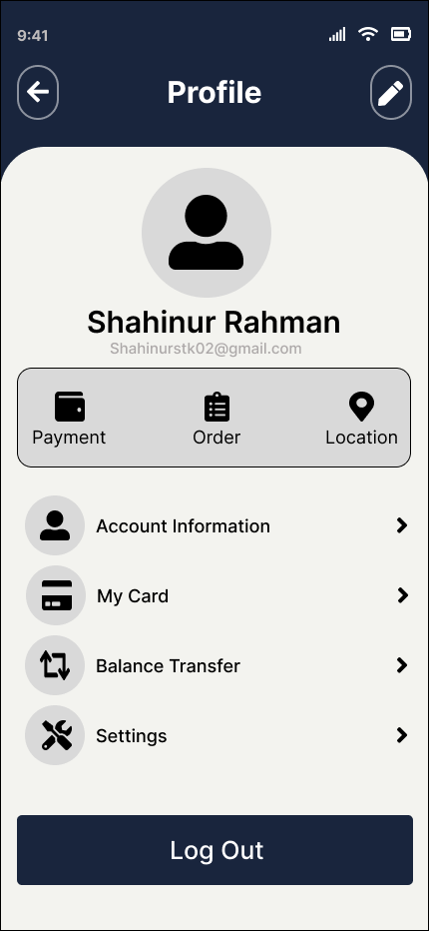

1. Edit User Profile Screen.

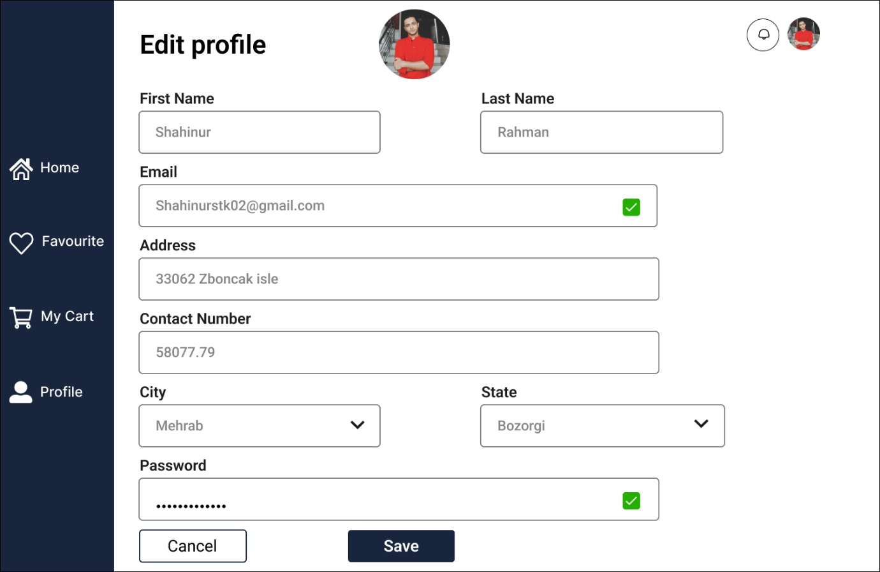

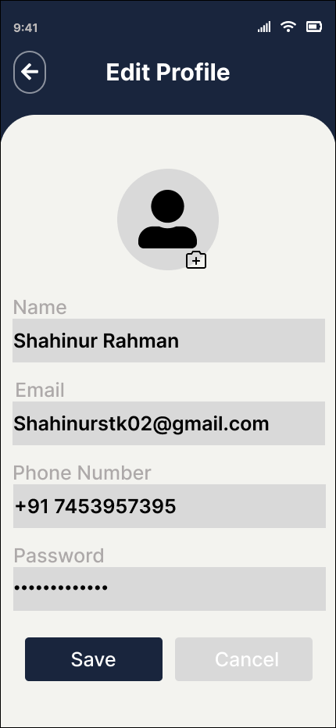

# Lab Practical #08:

1. Create screens to add/edit/view Cart Product information.
2. View Product Information Screen.

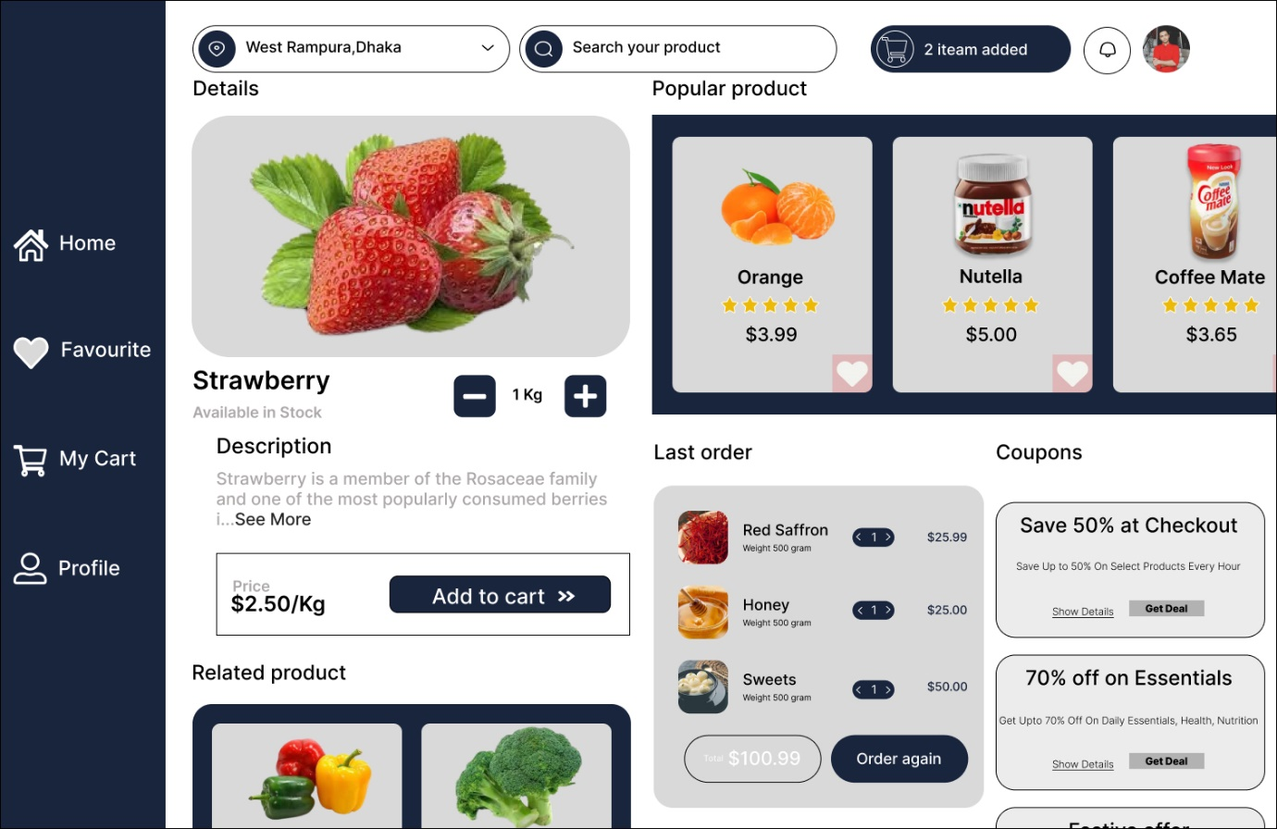

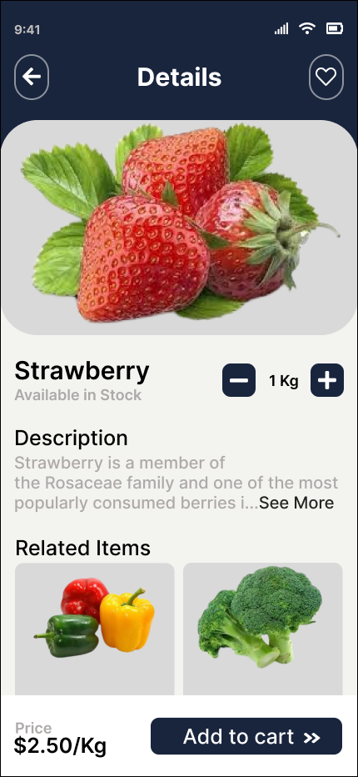

1. Edit Cart Information Screen.

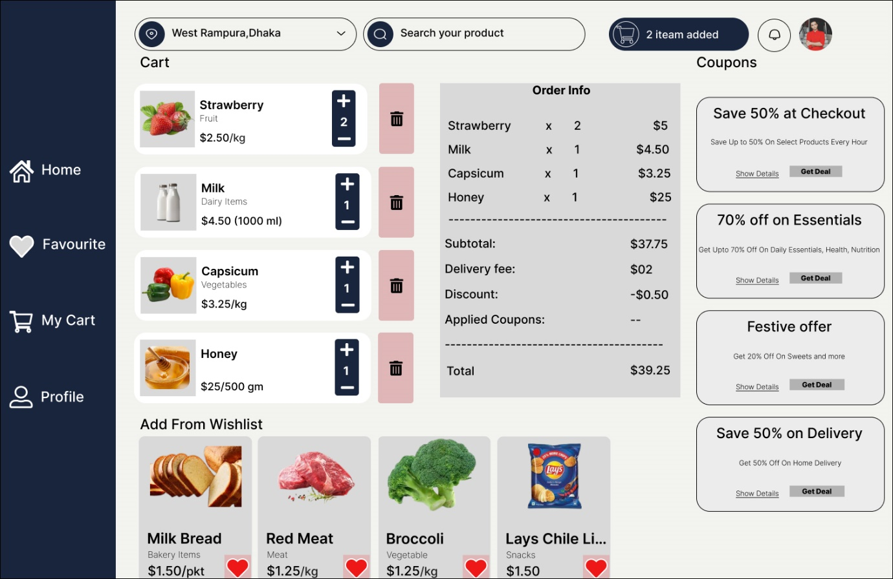

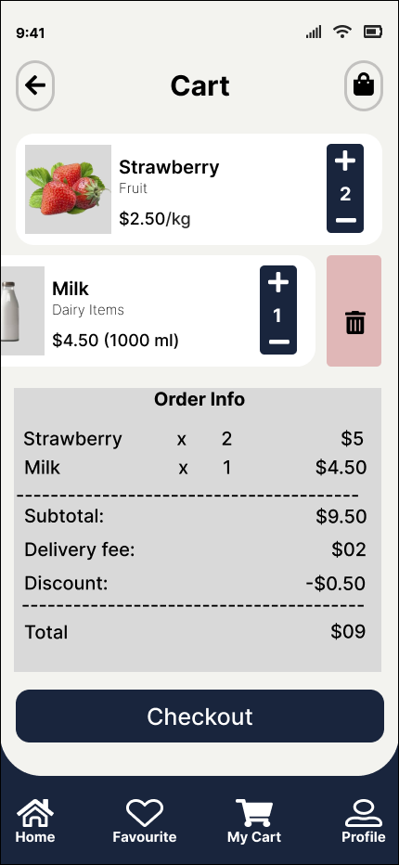

# Lab Practical #09:

1. Create screens for Wishlist.
2. Wishlist Screen.

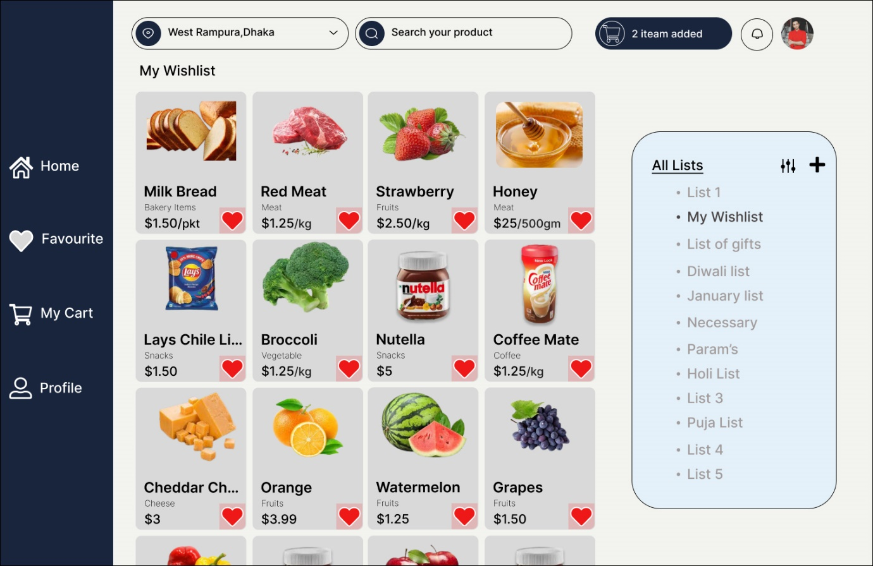

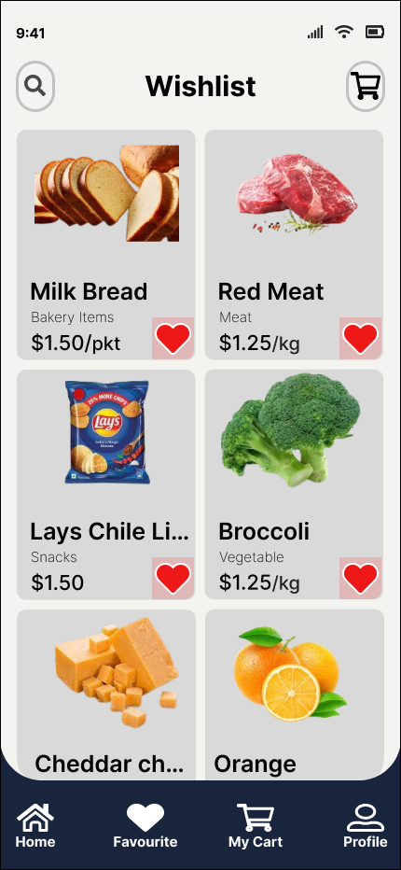

# Lab Practical #10:

1. Create screens for Notification.
2. Notification Screen.

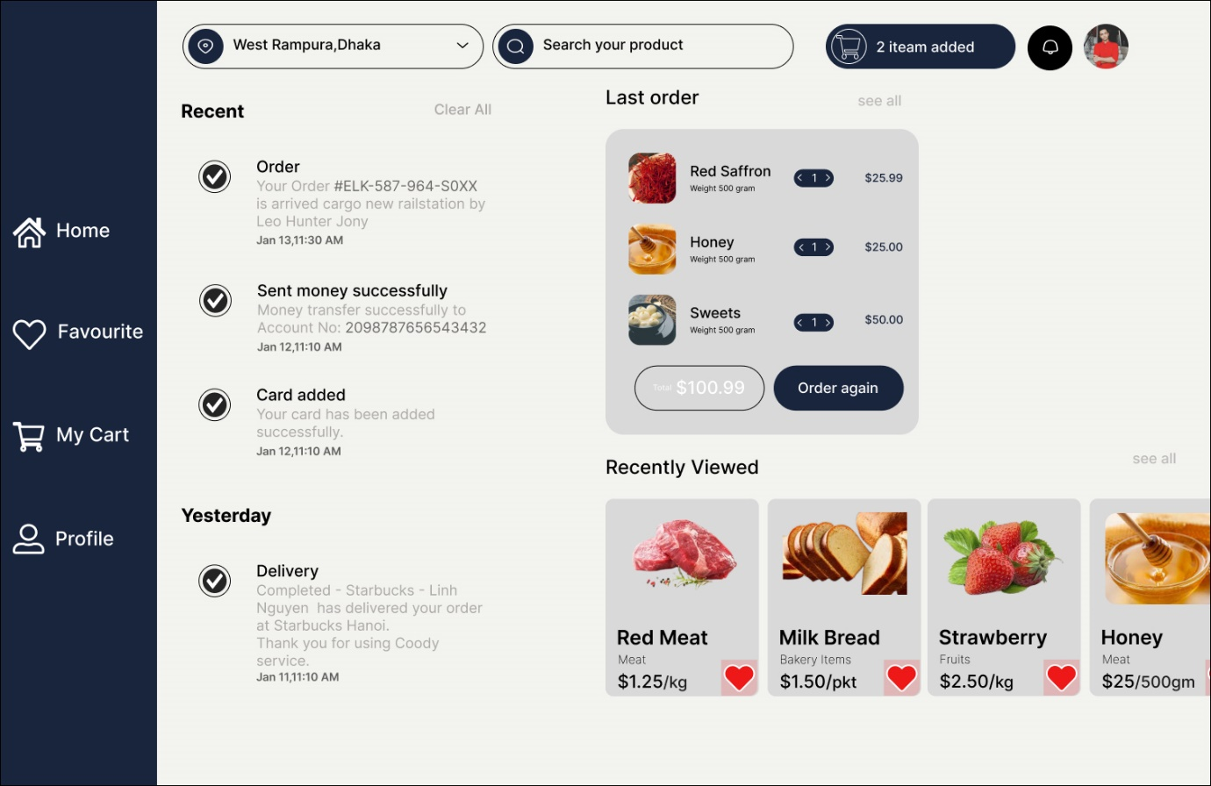

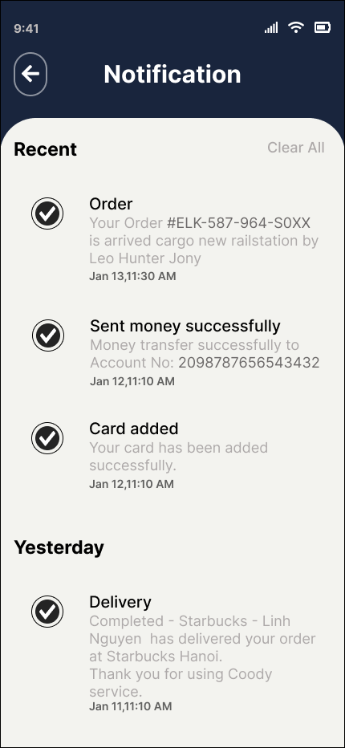

# Lab Practical #11:

1. Create screens to handle payment for the products in cart.
2. Payment Screen.

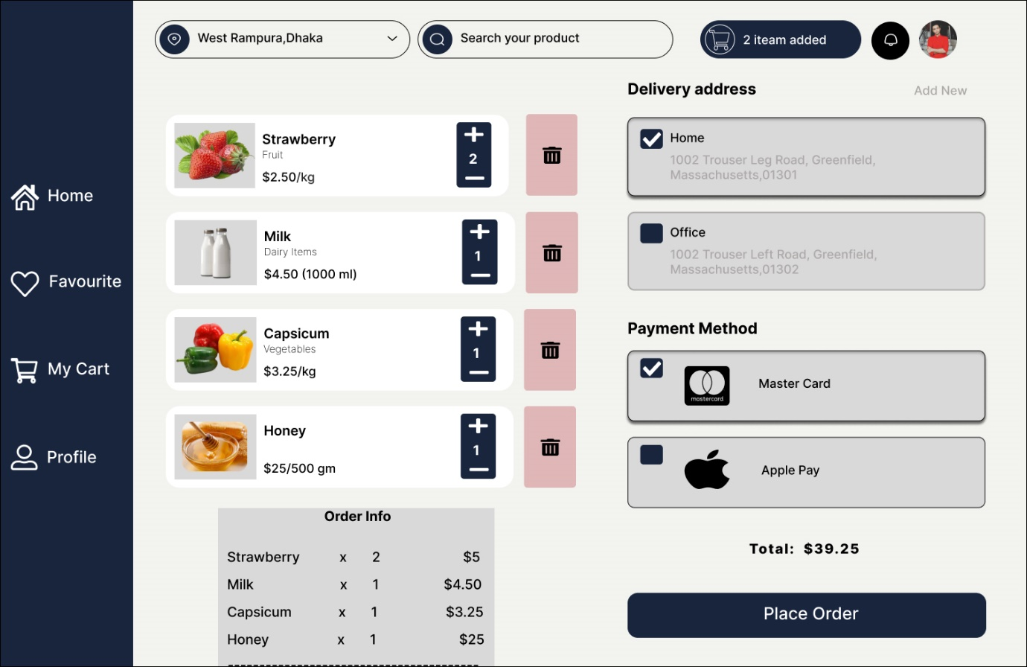

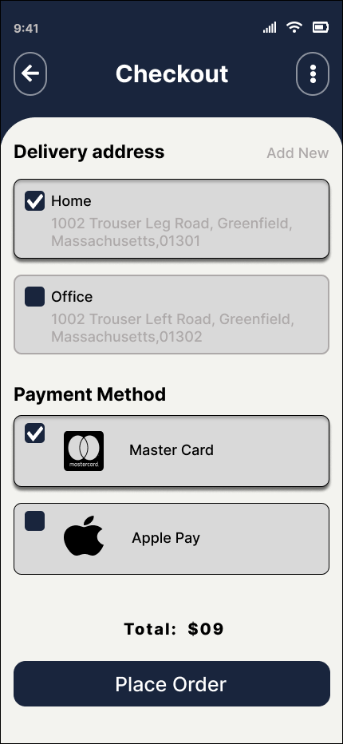

# Lab Practical #12:

1. Create screen to Categories information/ Search Product/ Apply Filters.
2. Categories Information Screen.

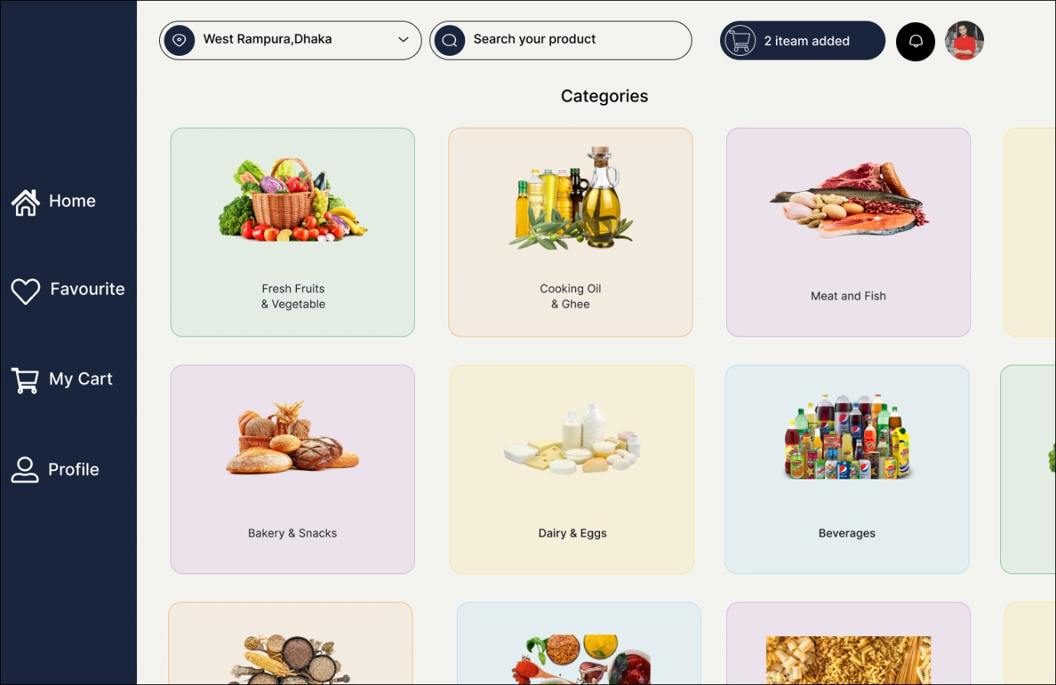

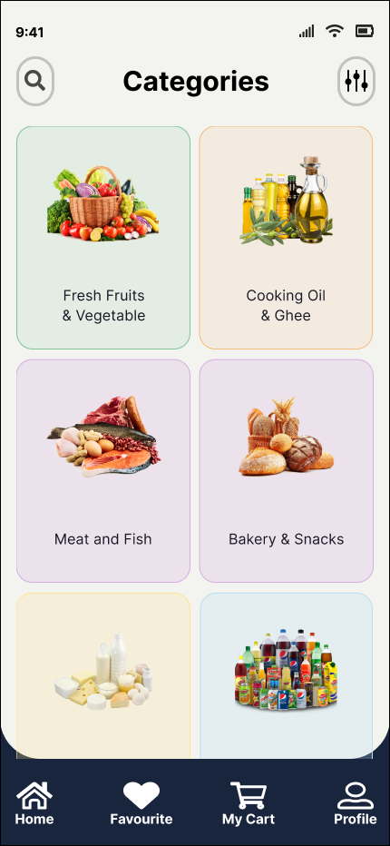

1. Search Product Screen.

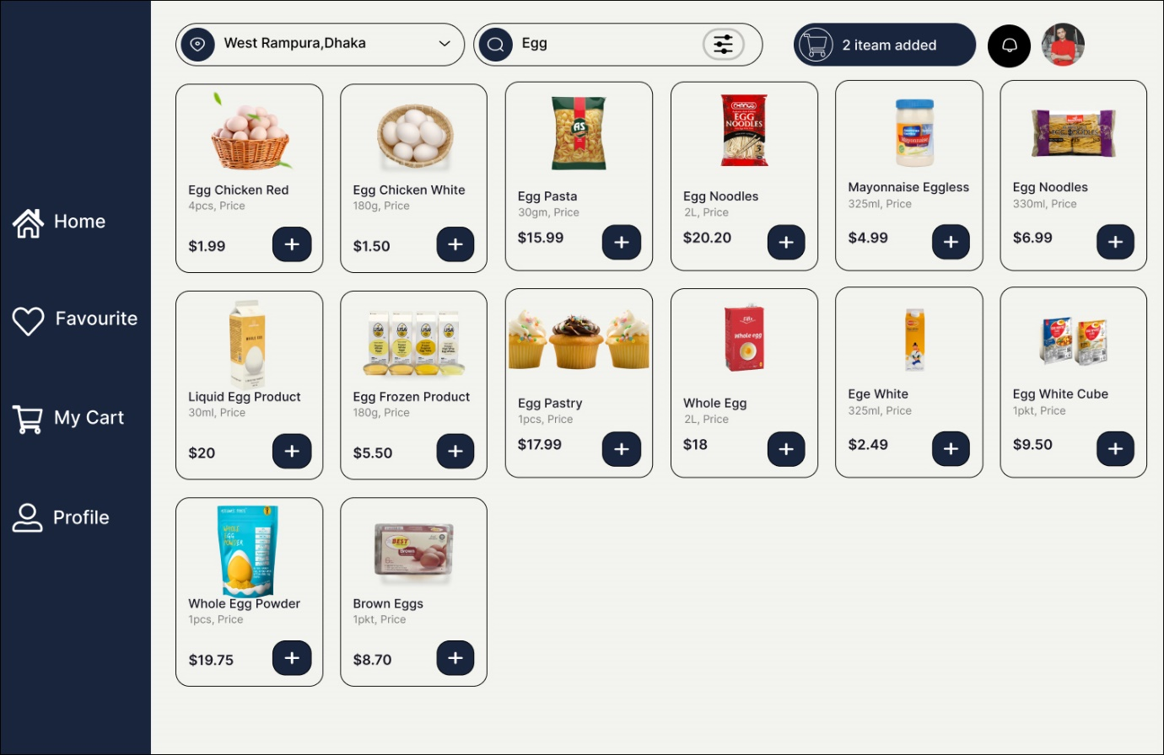

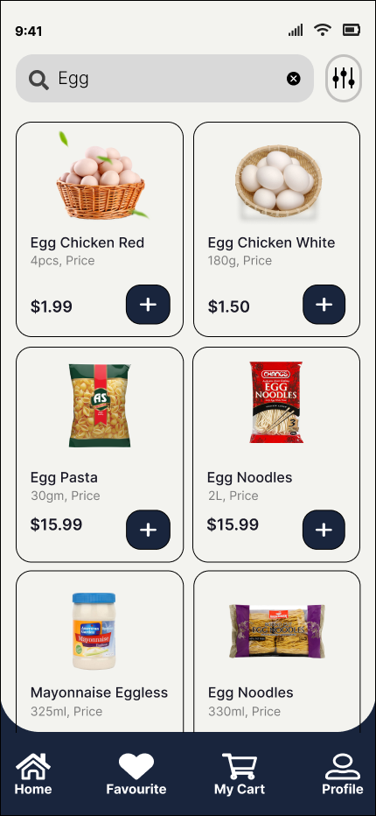

1. Apply Filter Screen.

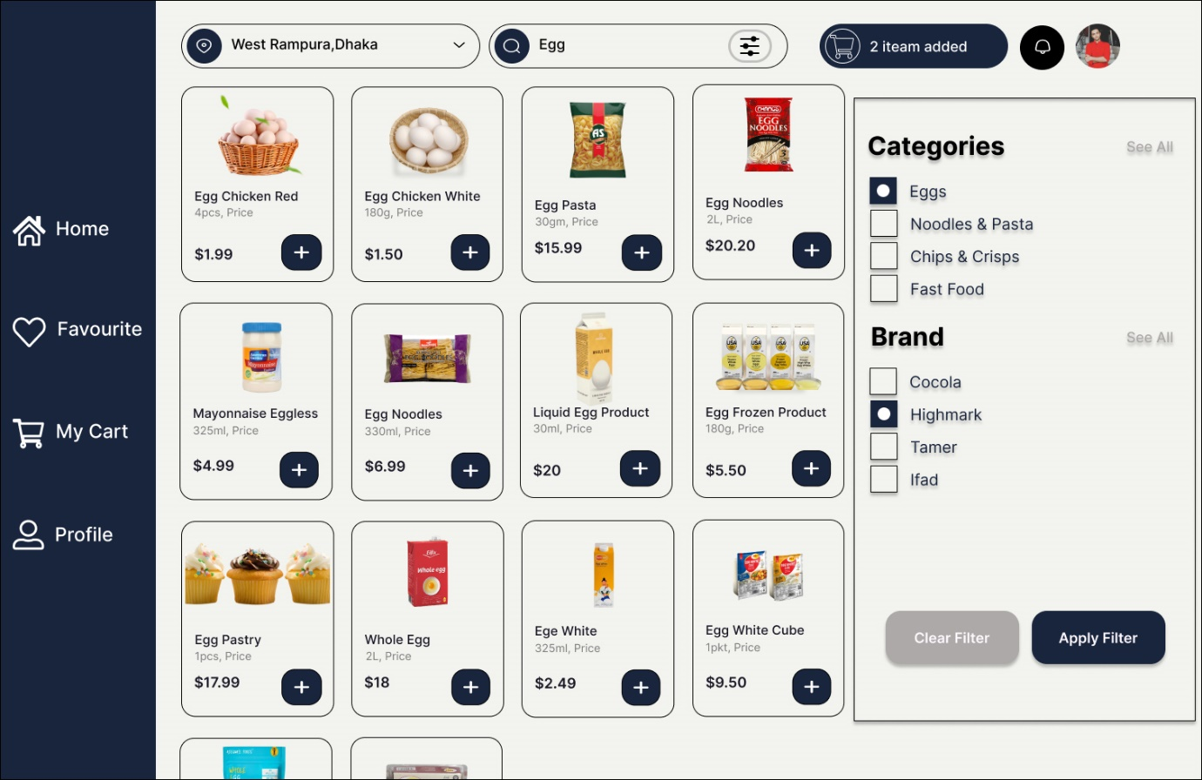

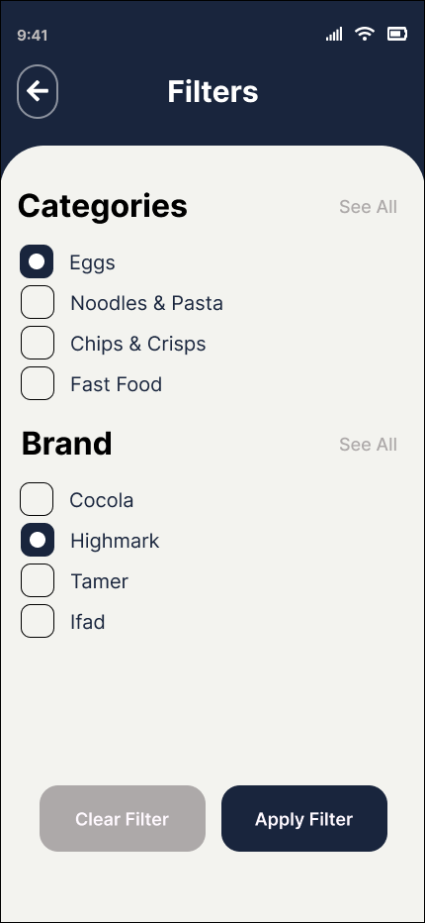

# Lab Practical #13:

1. Create screen to track records of the product purchased.
2. Product Purchased Screen.

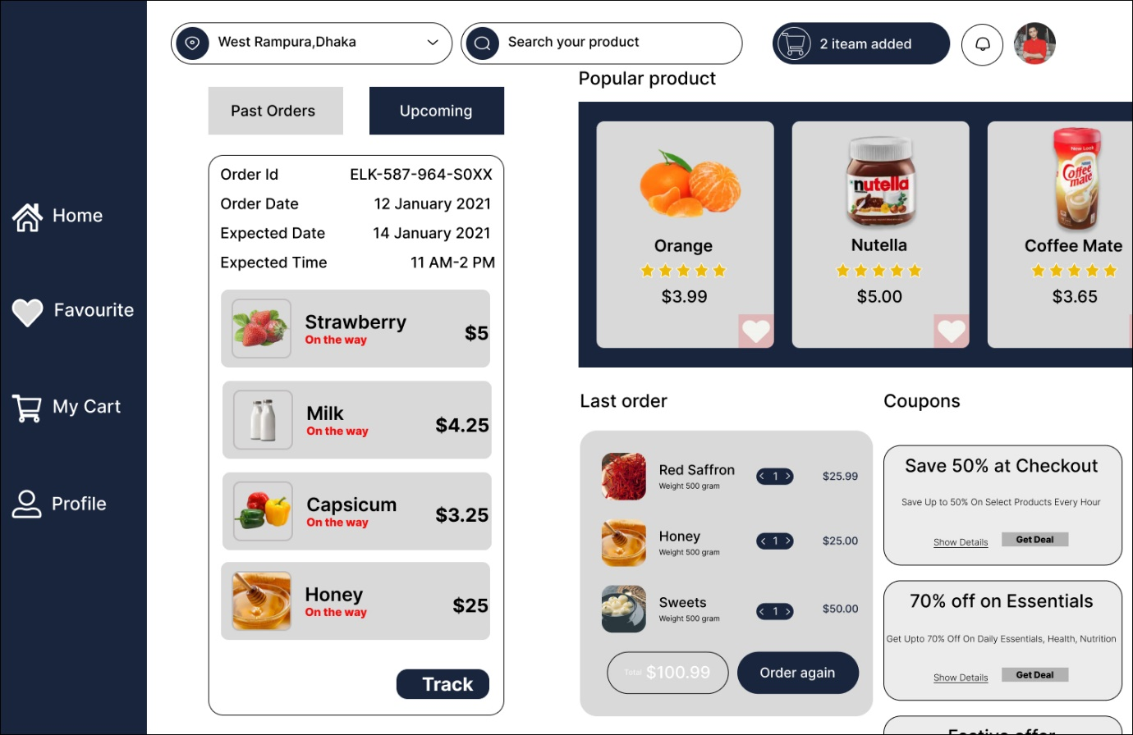

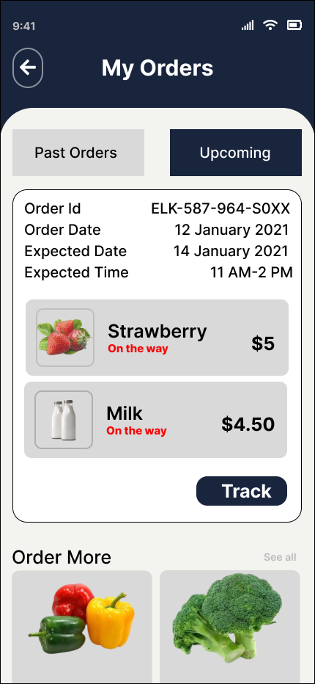

1. Product Purchased Tracking Screen.

